**Database Design**

This section describes one or more physical network (hardware) configurations on which the Comestics Shop Management System is deployed and run. The system is comprised of these mandatory physical nodes: two firewalls (internal and external), a web server, a database server and a backup database server. The diagram below is the simplicity version of the Comestics Management System deployment view.

Having trouble with deployment diagram - Stack Overflow

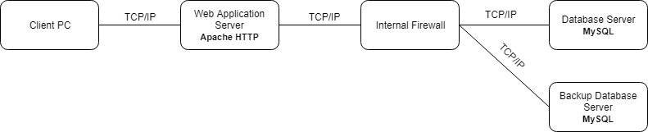

ERD

